Piotrek Co., Ltd.
【Battery Japan】Booth Location Guide
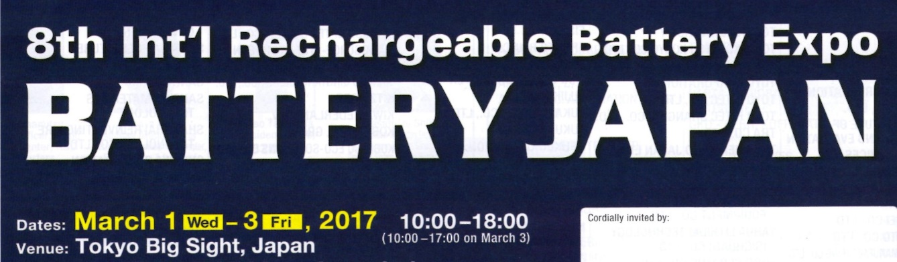

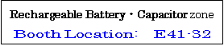

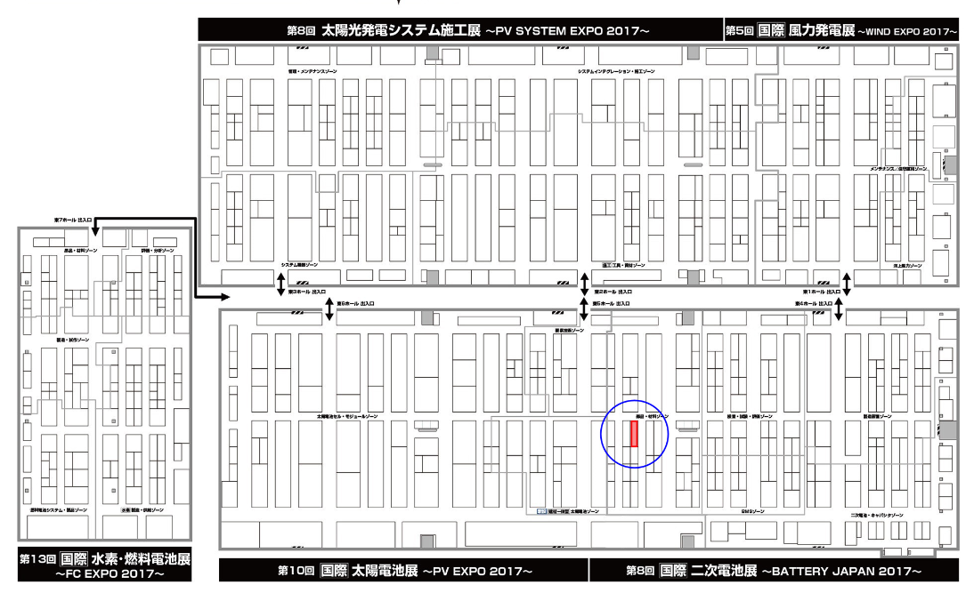
East 5 hall

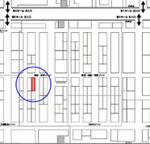
Rechargeable Battery・Capacitor zone

Exhibiting contents：
- Ion Conductive Polymer(so called “CP”), Ion Conductive Binder(so called “CB”)
- Solid-state Electrolyte, solid-state style LIB cell, Demonstration of this LIB cell
- CP coating Separators and its coating technology by this coating machine
- PelLicleTM(LIB) Flat Cells assembled module
- CleanliteTM モas a mobile solar power carry bag installed the modules
- Contract Research & Examination like Assessment for LIB Materials, LIB cell and Safety tests as well as Technology Consultant in overall field of LIB technology.
- Assistant role for development works of LIB tech. conducted by customers

Your visit toward our Exhibition Booth is
always welcome during this period !!

